Change Management:

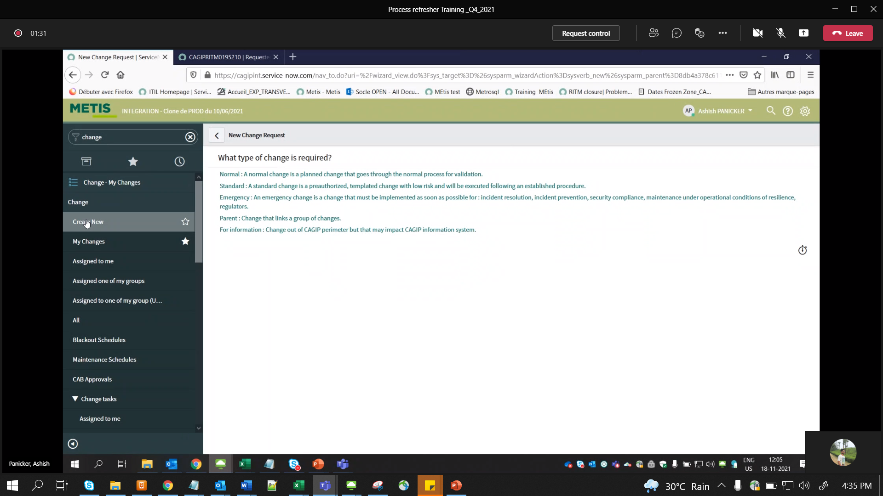

Std Change – pre defines / Pre approved Changes

Add all CI’s

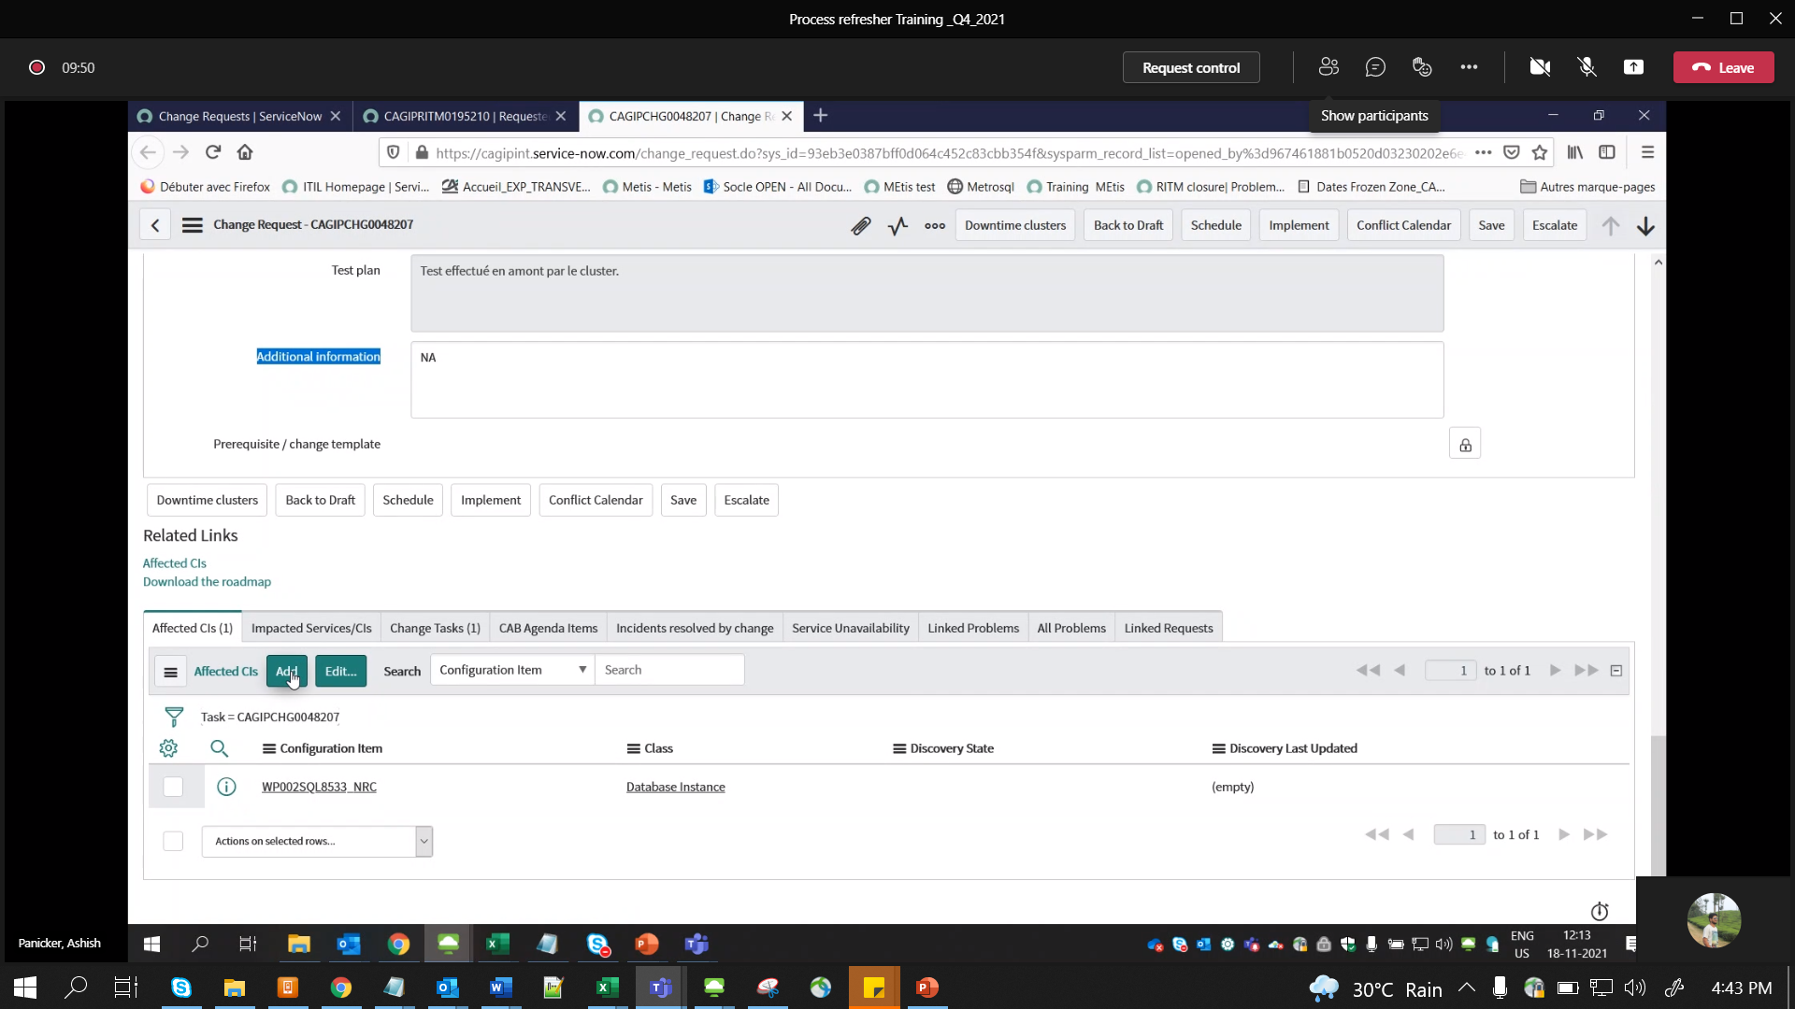

MANDATORY – Change Task :

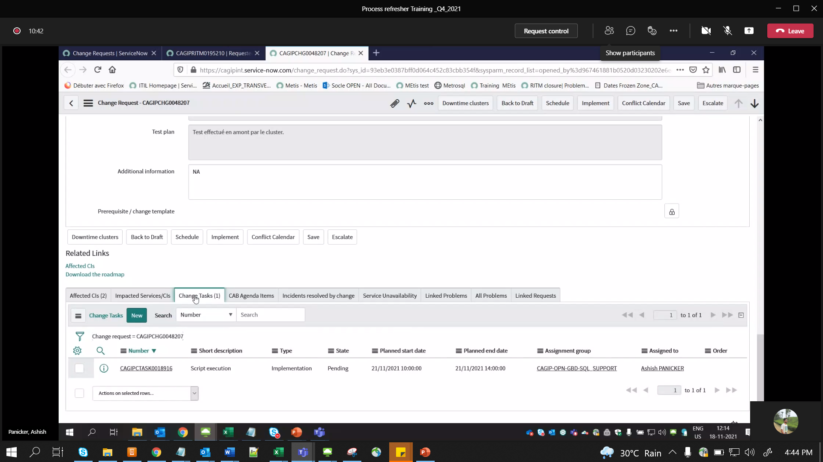

v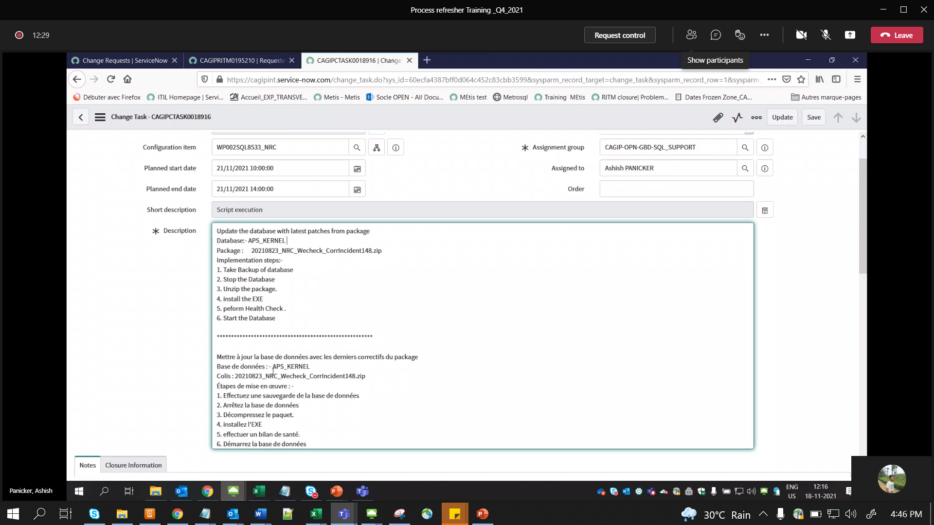

Mand. Field

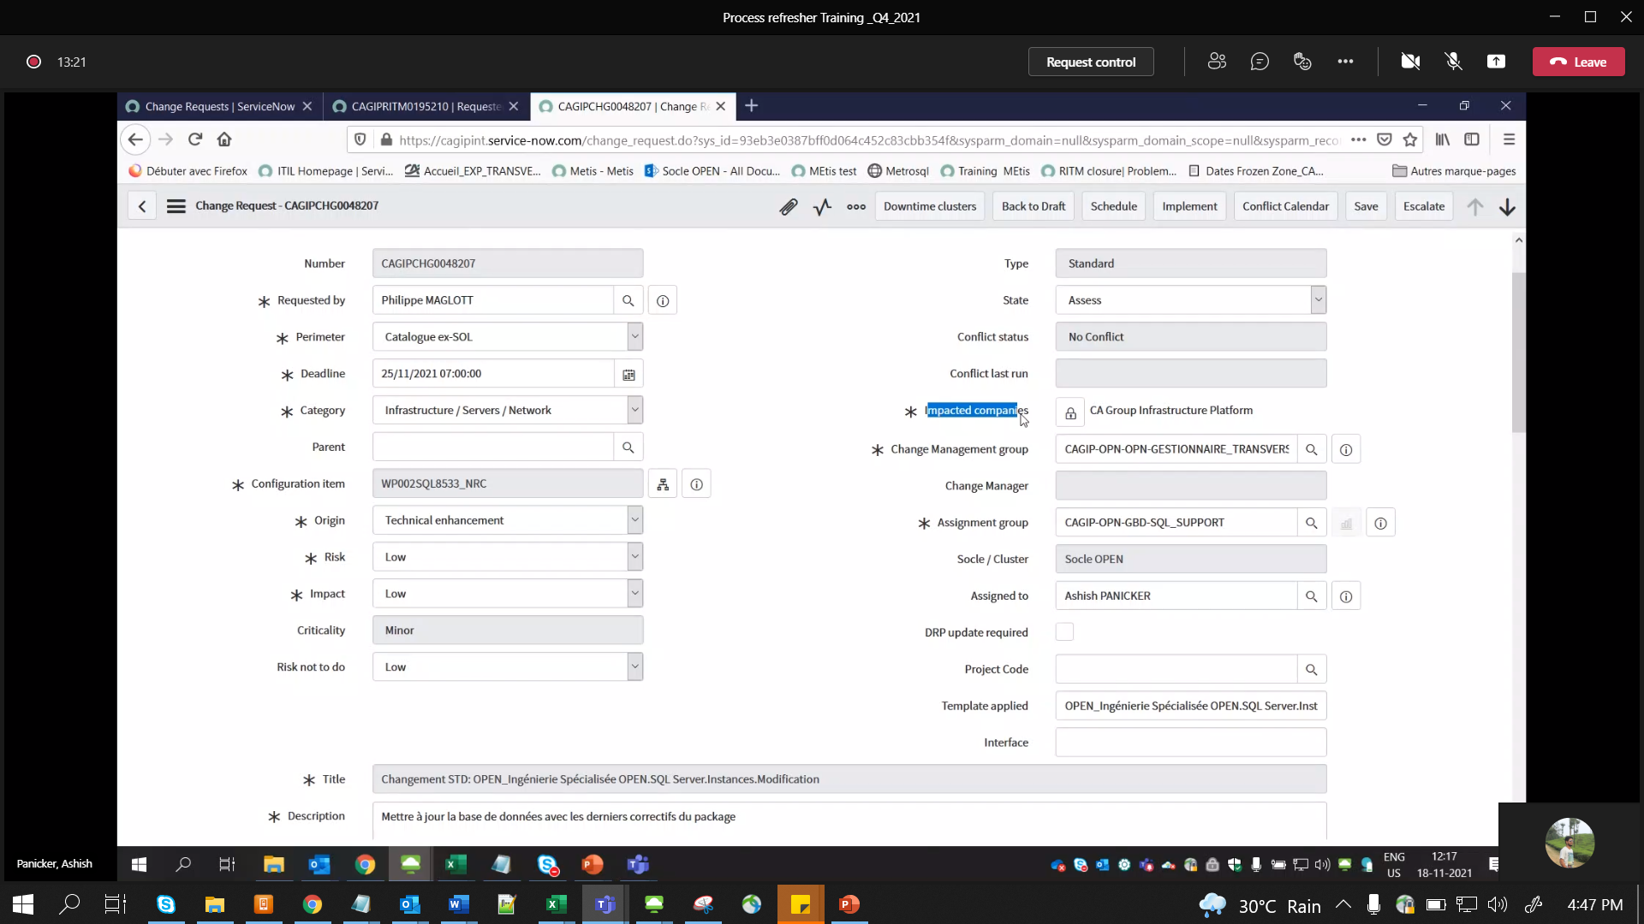

Approval Groups:

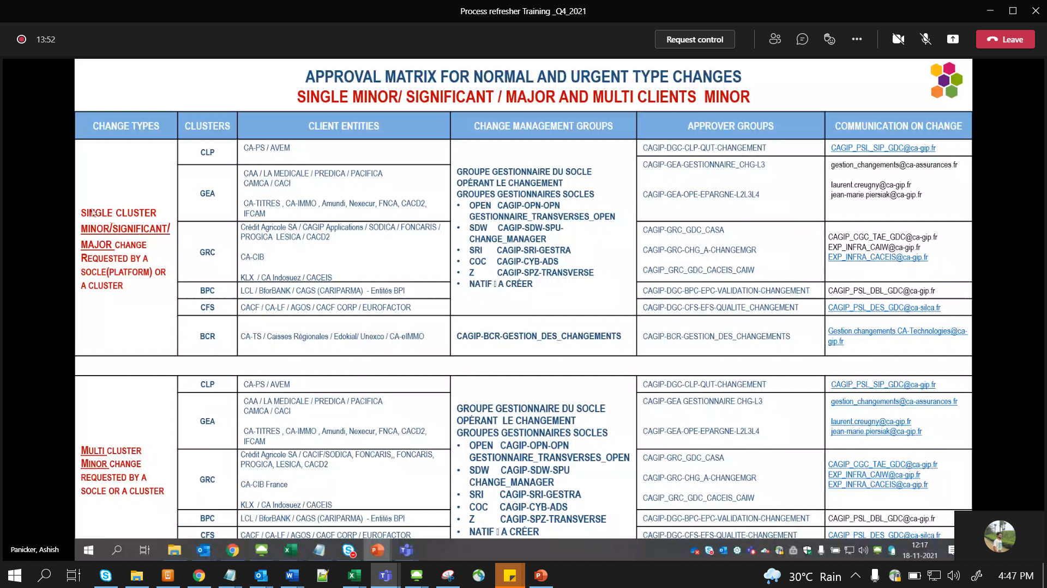

For CATS – BCR

Rest all CAGIP – OPEN CAGIP-OPN-OPN-GESTIONNAIRE_TRANSVERSES_OPEN

Once all activities completed - Close CATSK:

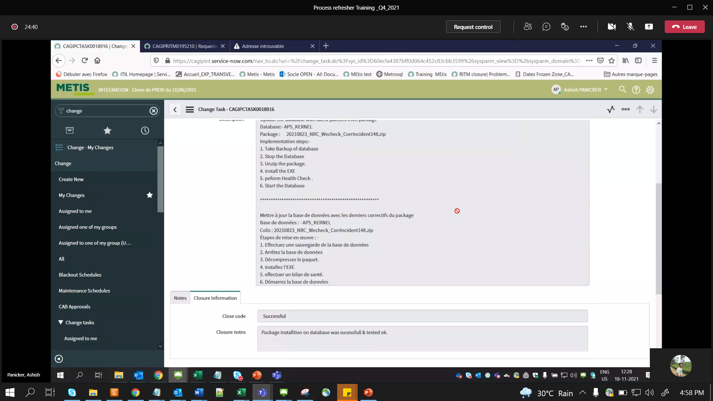

Review:- Update Actual Start/END date/times in this stage

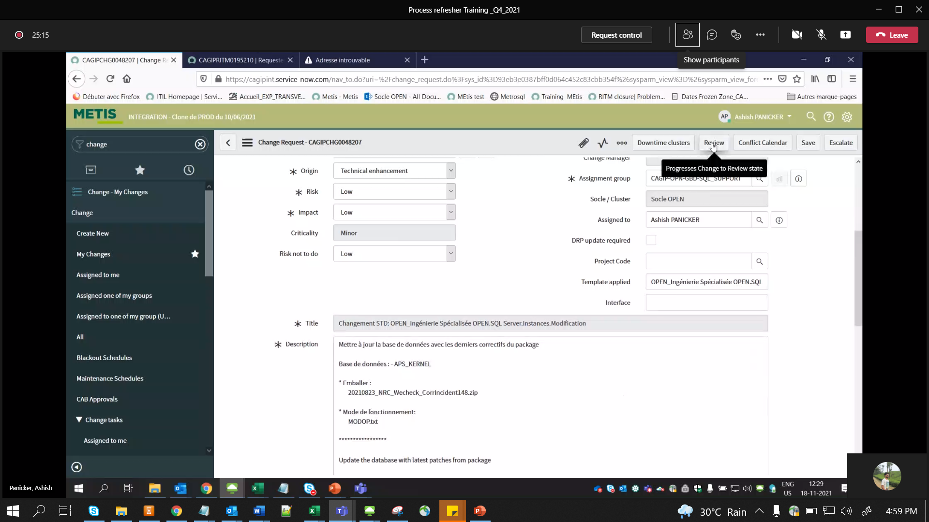

Before moved to Closed phase:

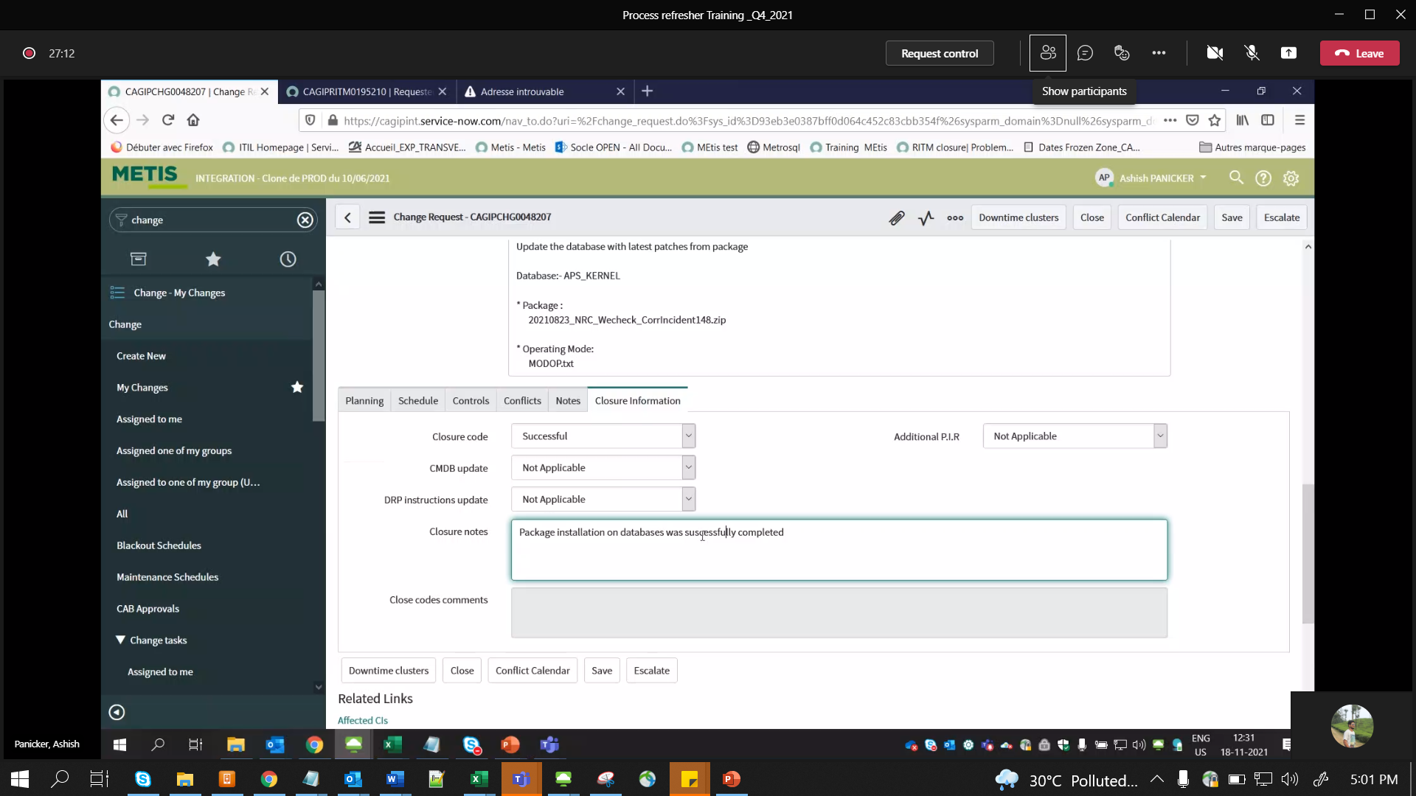

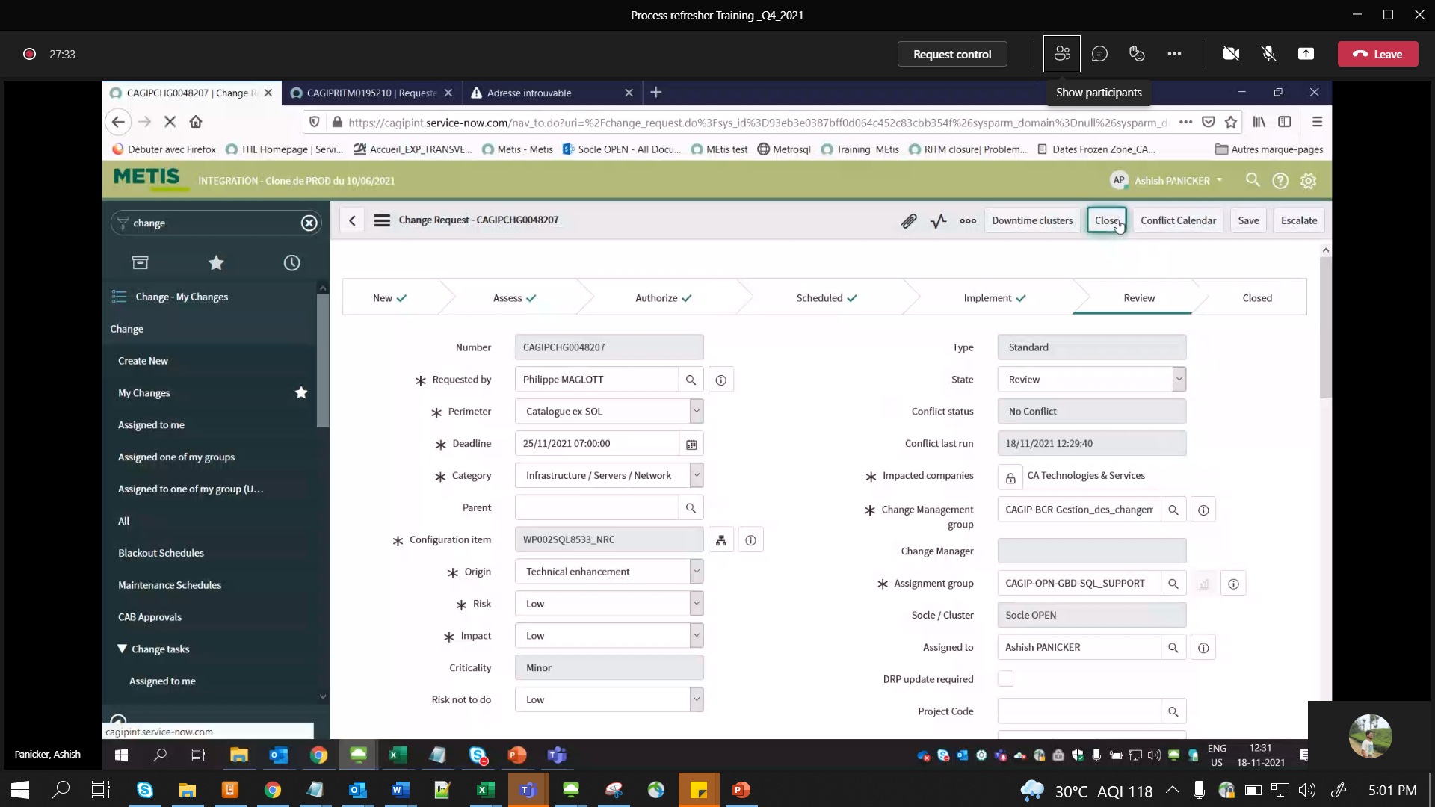

Normal Changes:

Blackout window:

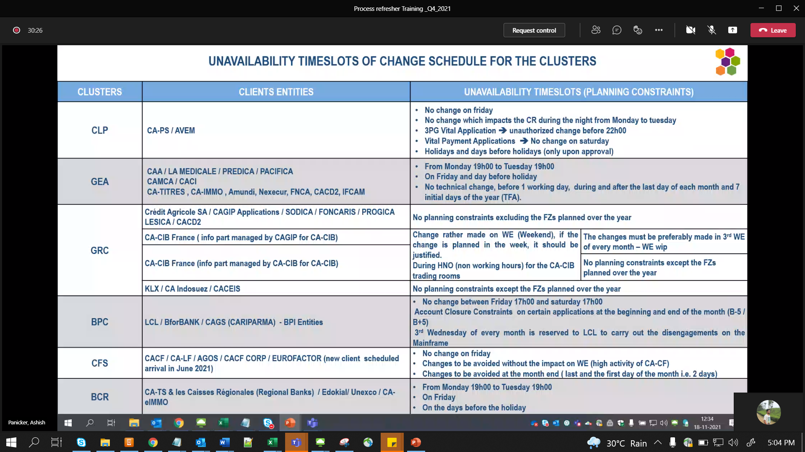

Change cancellation:

[5:08 PM] Ansari, Ikramuddin

For Change :-

--> If you want to cancel the change ticket until Schedule state, you can send email to - IN, PEPS CHANGE MANAGEMENT <pepschangemanagement.in@capgemini.com> to cancel the change alongwith reason for cancellation & we will do that for you.

--> If your change is moved to 'Implement'/ 'Review' state bymistake without performing any action, then we need to raise INC to metis team : CAGIP-SIS-METIS-SUPPORT mentioning the final state to be updated as 'Canceled' and reason for cancellation.

For RITM :-

--If you have the RITM which needs to be closed/ canceled from backend, then an INC needs to be raised to METIS team : CAGIP-SIS-METIS-SUPPORT with the correct stage/ state (Eg: Completed --> Closed processed or Completed --> Closed Cancelled)

like 2

Freeze Periods:-

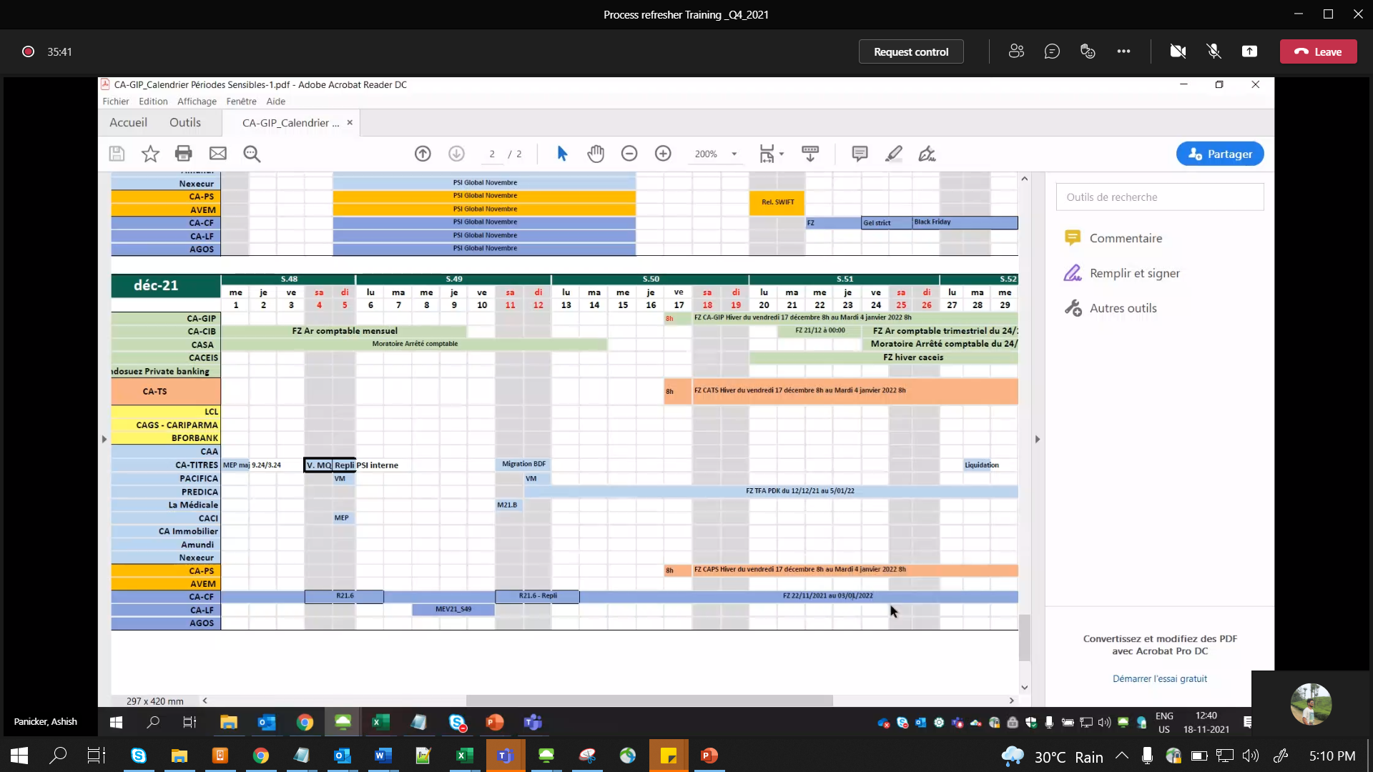

CAB:-

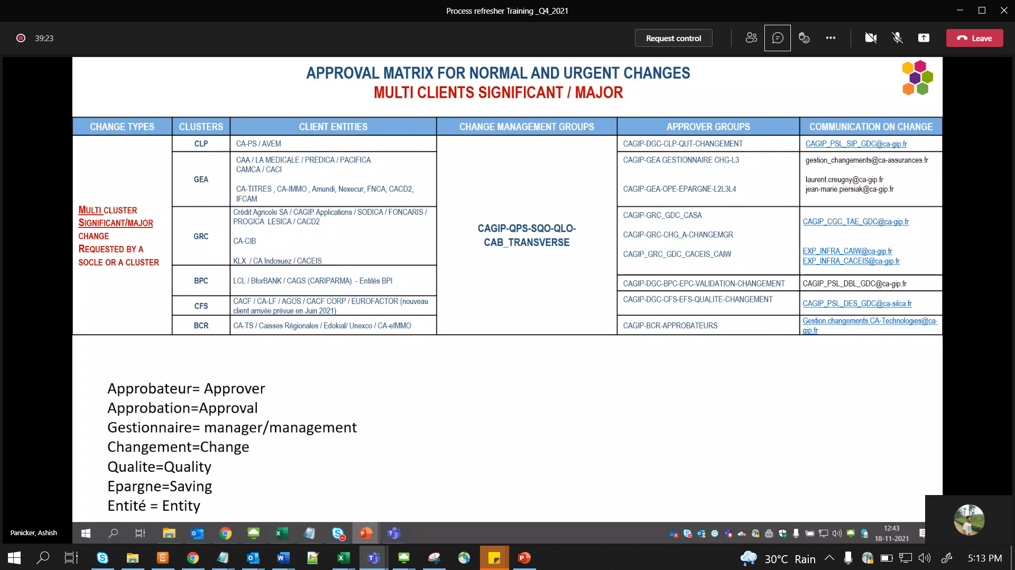

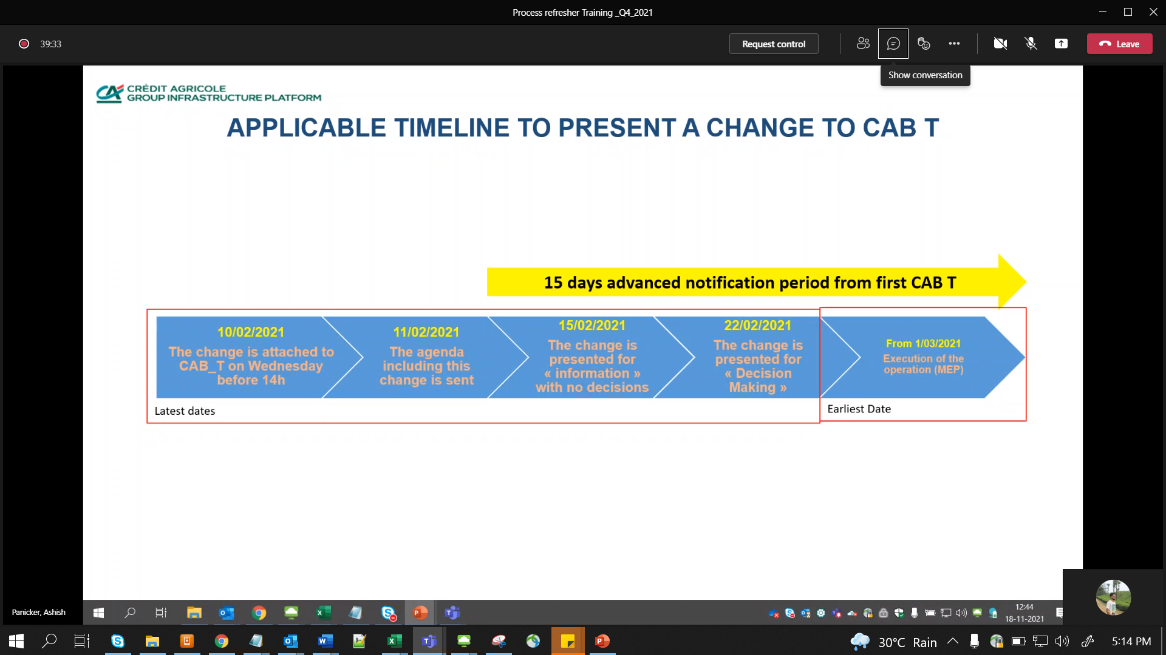

Our Cab call – Monday 2 pm CET

Impact & Risk assessment:

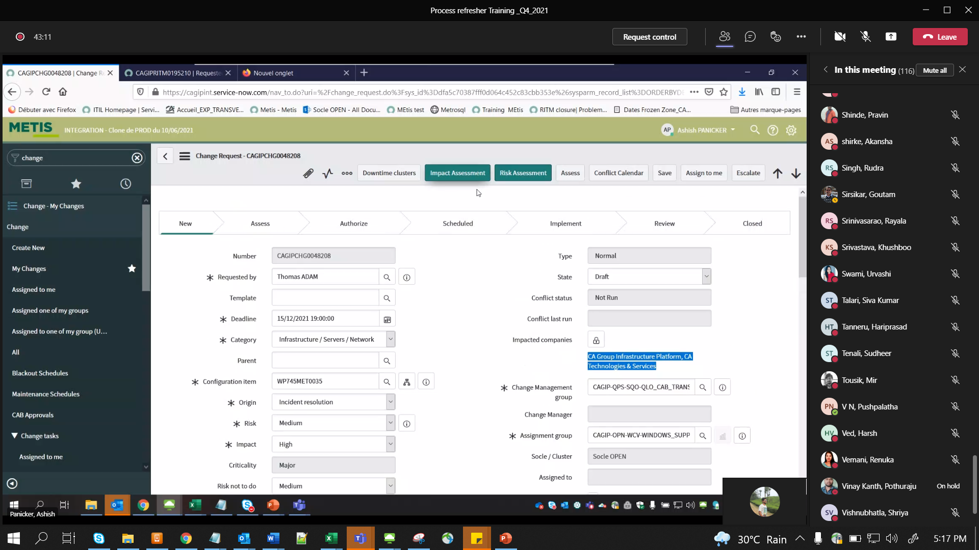

FDR:

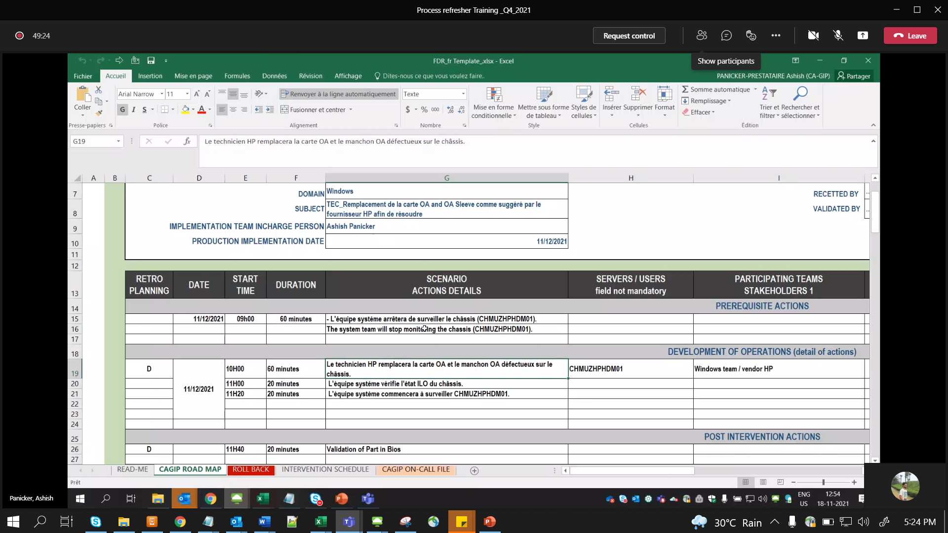

First section =Pre -Req

Middle is d D day = Main task

Last = Post

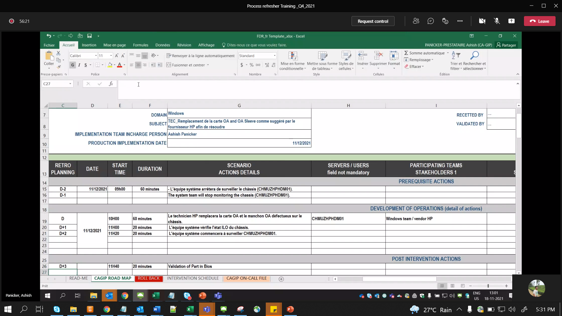

Approvers:

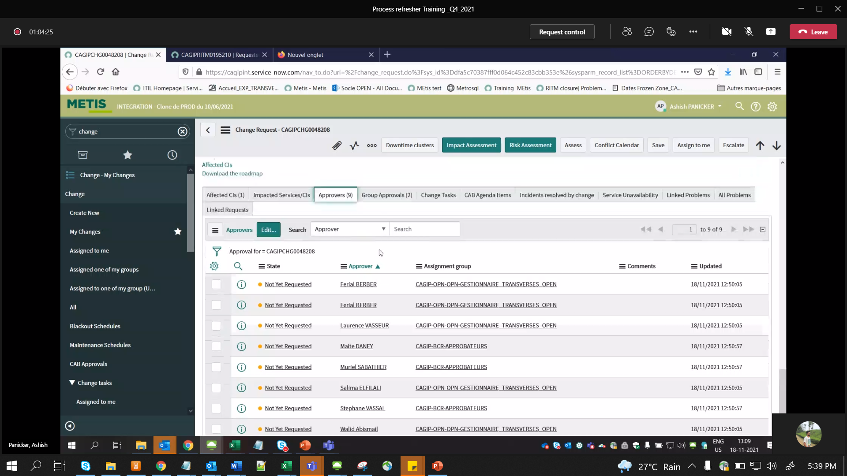

If we need to add more Approvers group:

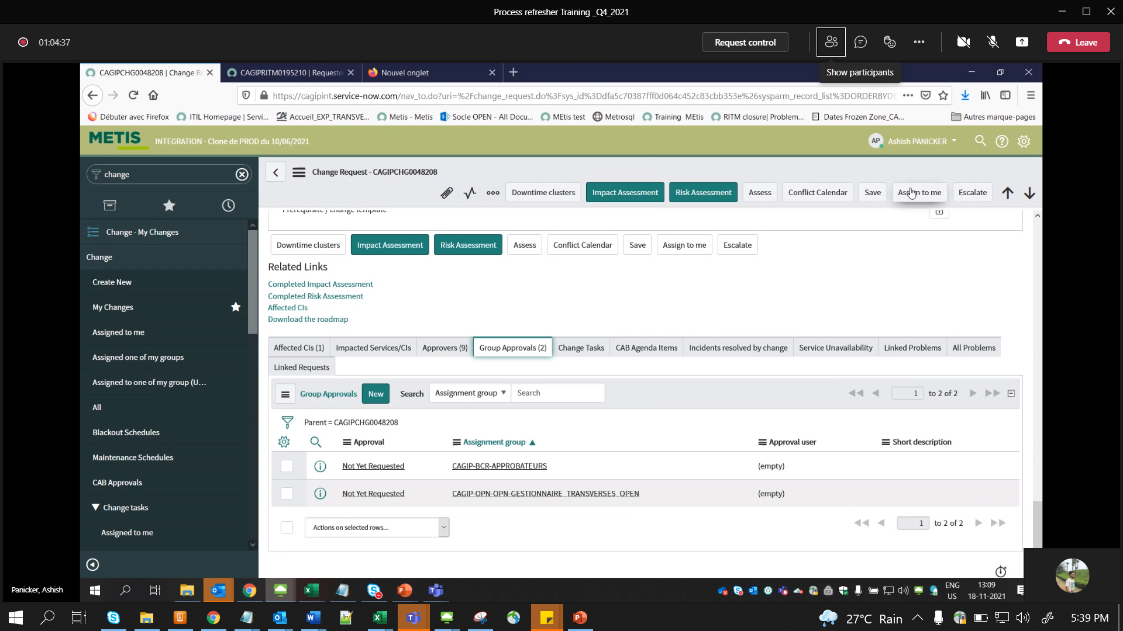

Move change before Wed 2 PM CETs

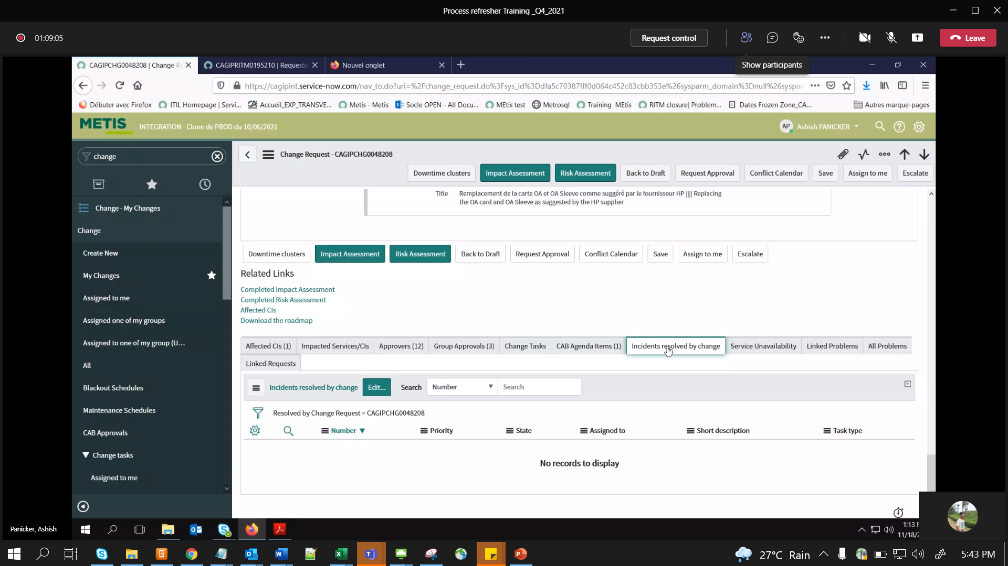

We can Link PB, RITM etc..

After all Approvals (one from each Approver group), it will can be moved to Implement

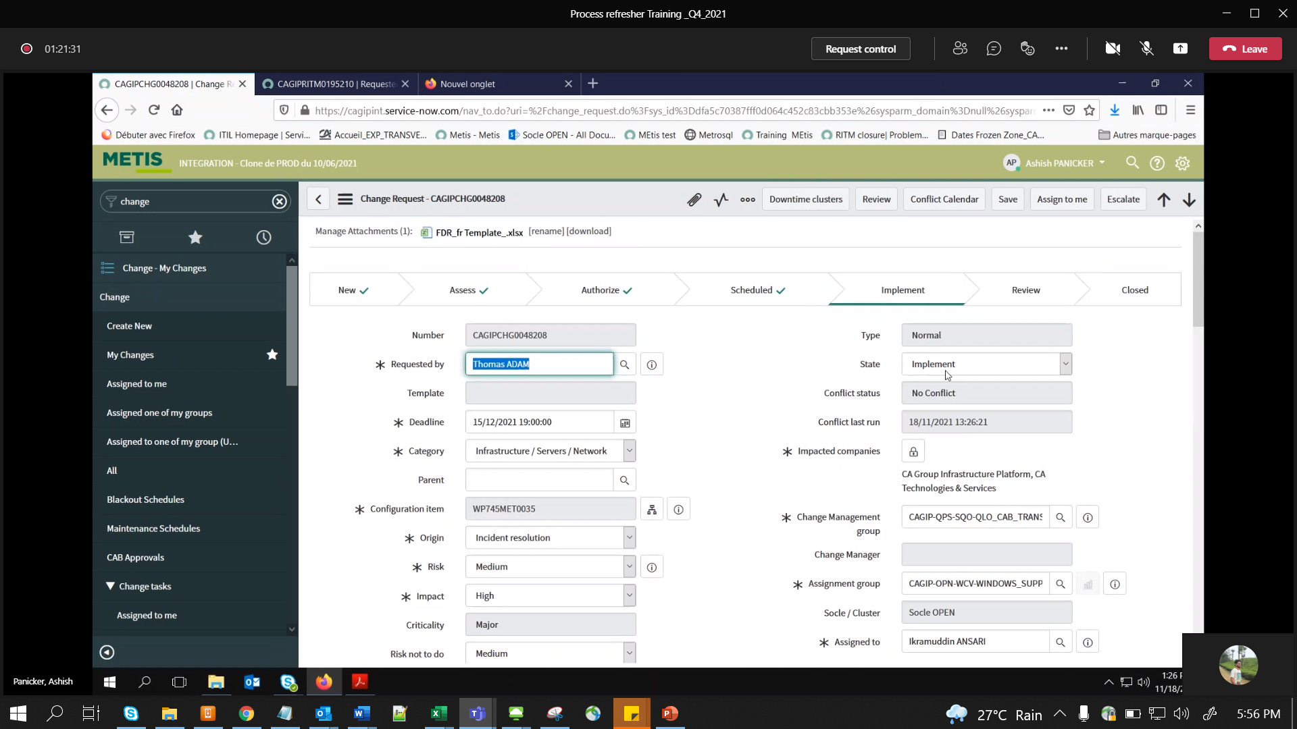

Mail from, Metis itself:- while performing in Implement phase (mail option in 3 dots)

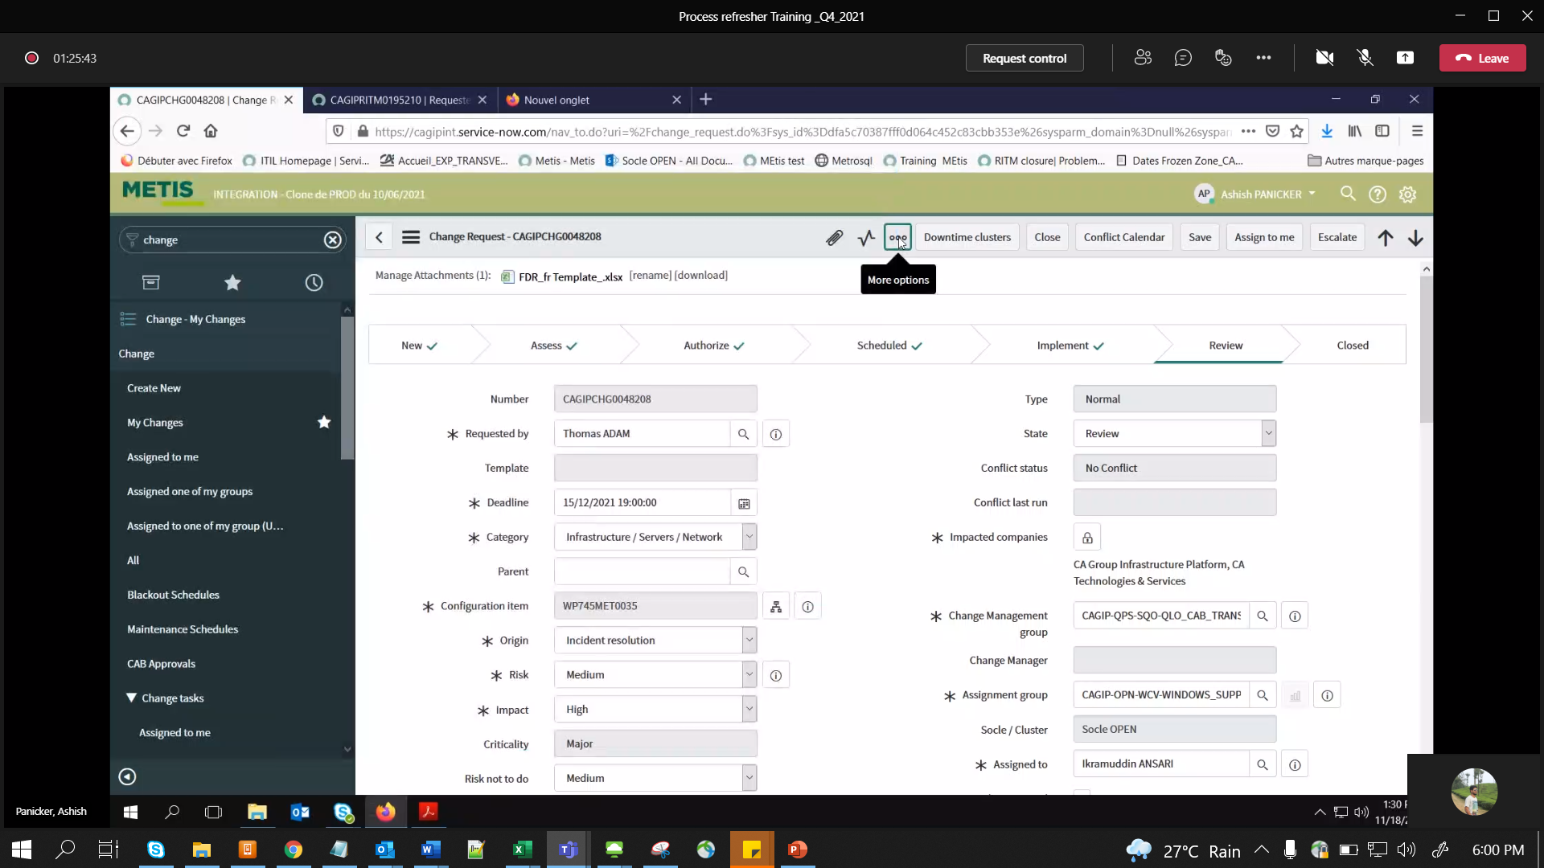

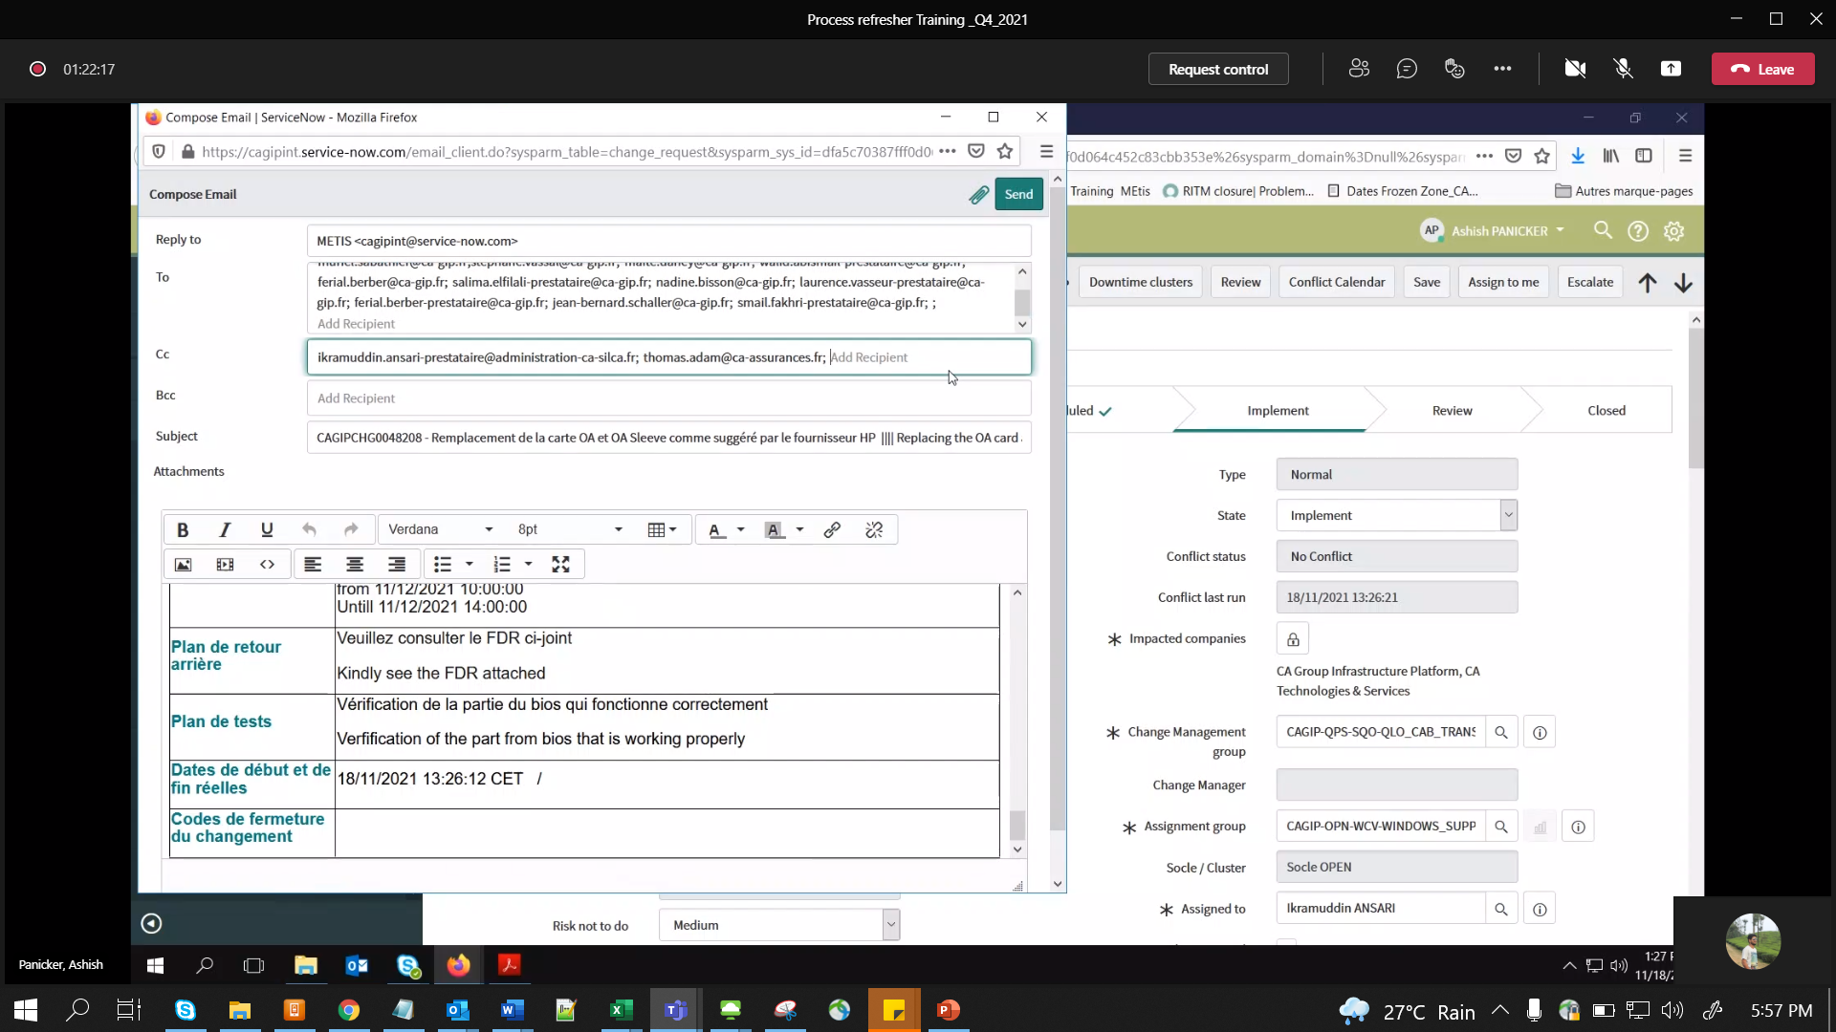

U can add more Cagip email ID’s:

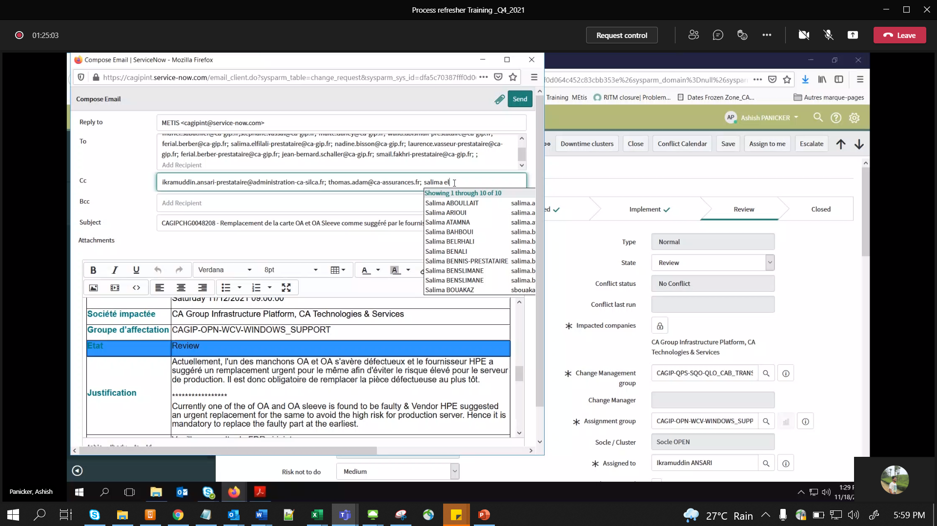

Once all CTASK’s closed (V.IMP Correct Imputation Code , don’t put TBDEF..This is for cost calc.)

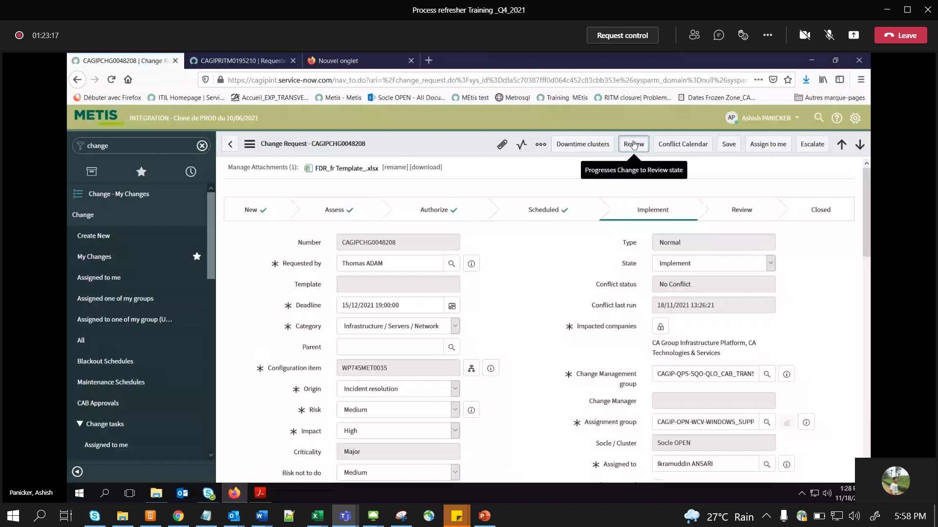

Then sent mail:

Last 2 fields is V.IMP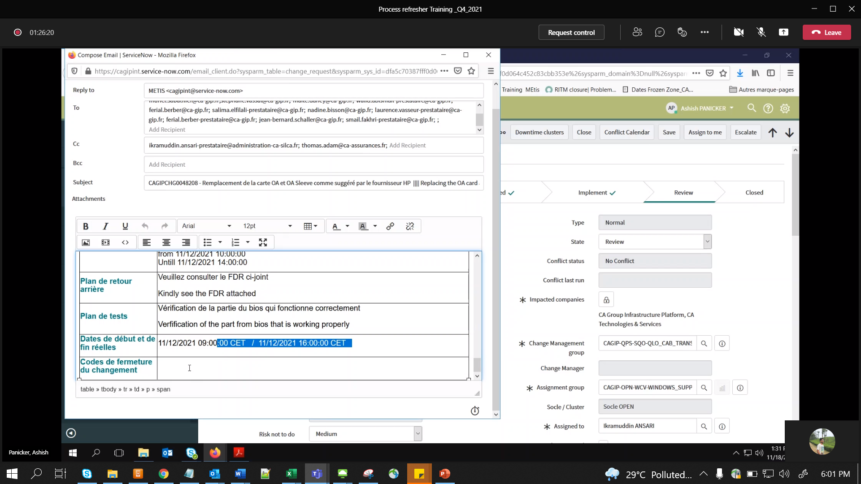

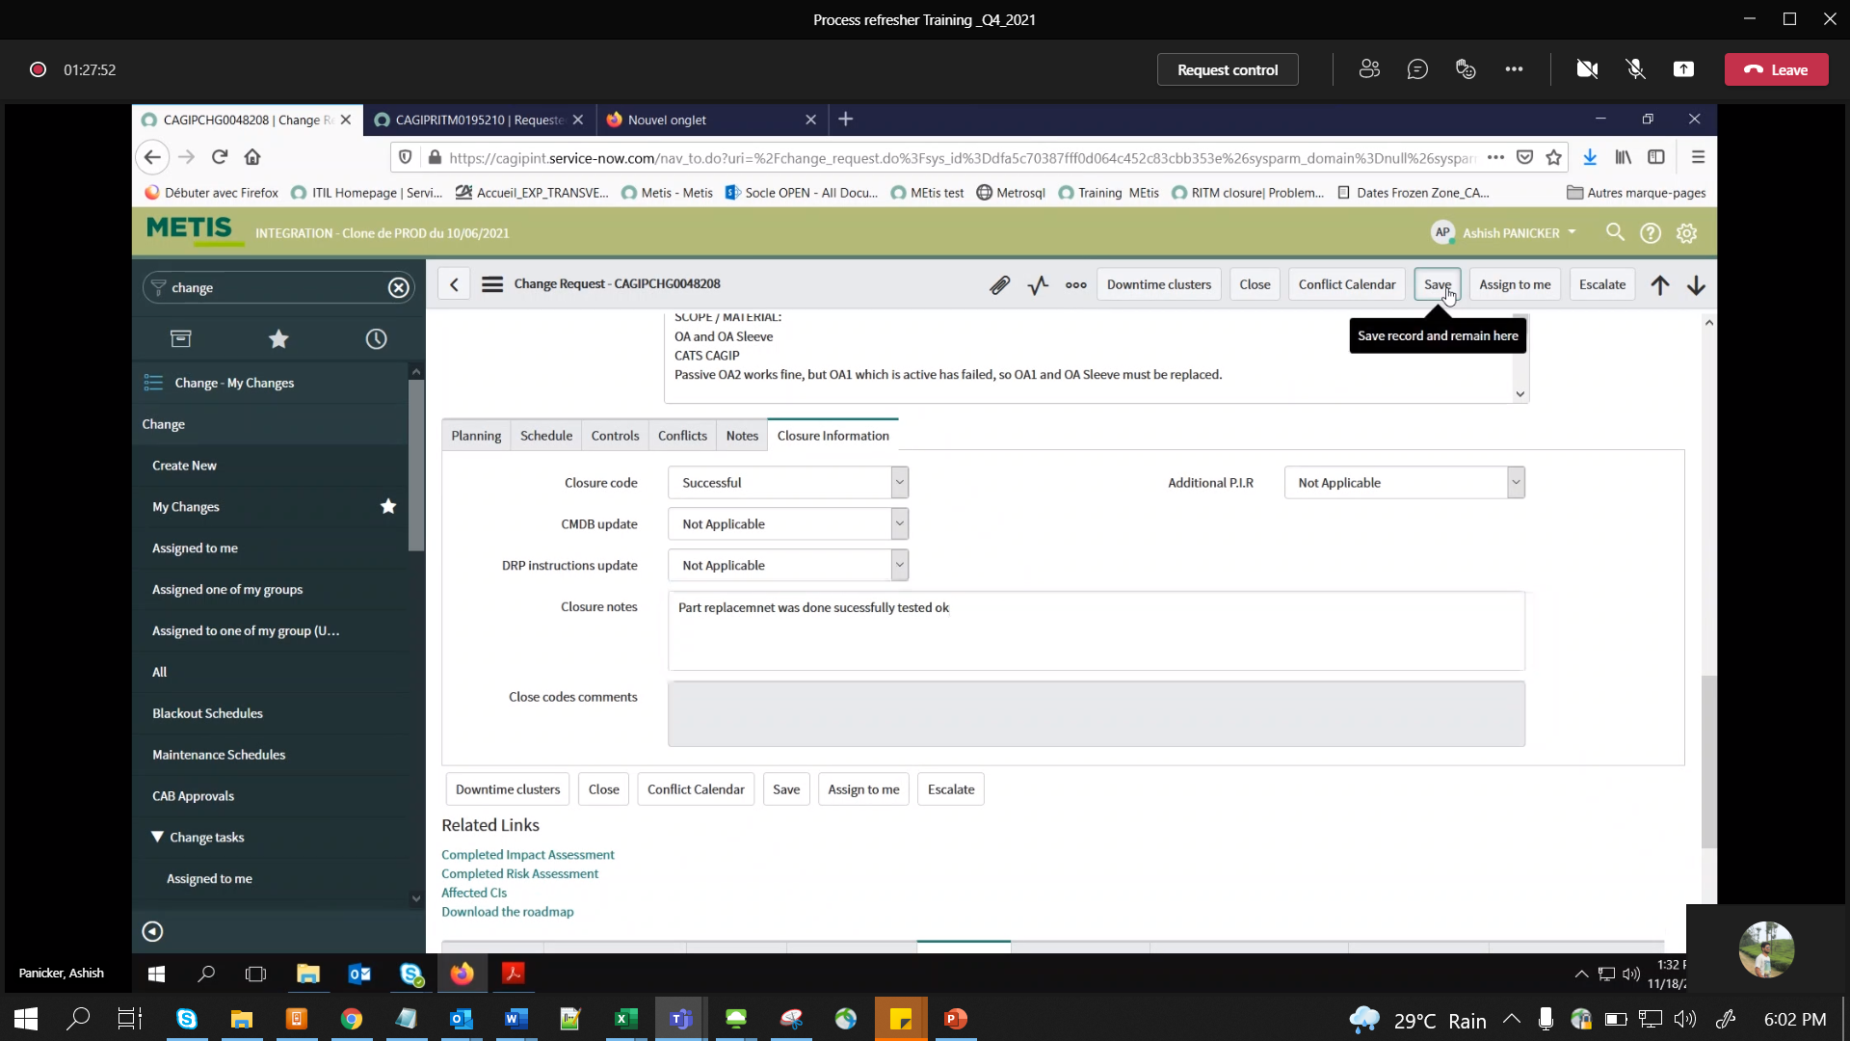

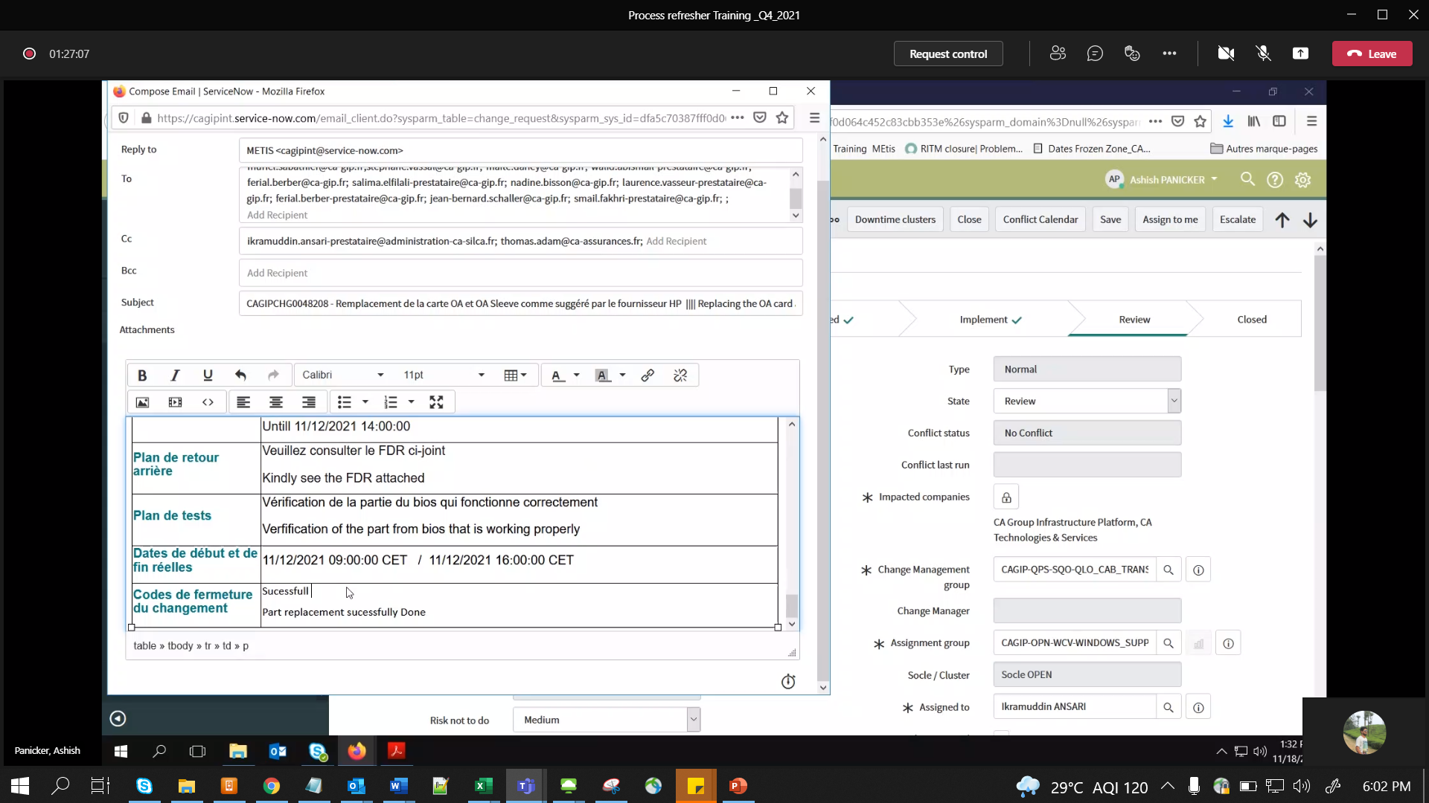

NB:- COMMN in FRENCH

Non Prod Changes: - fill form for CAB Y

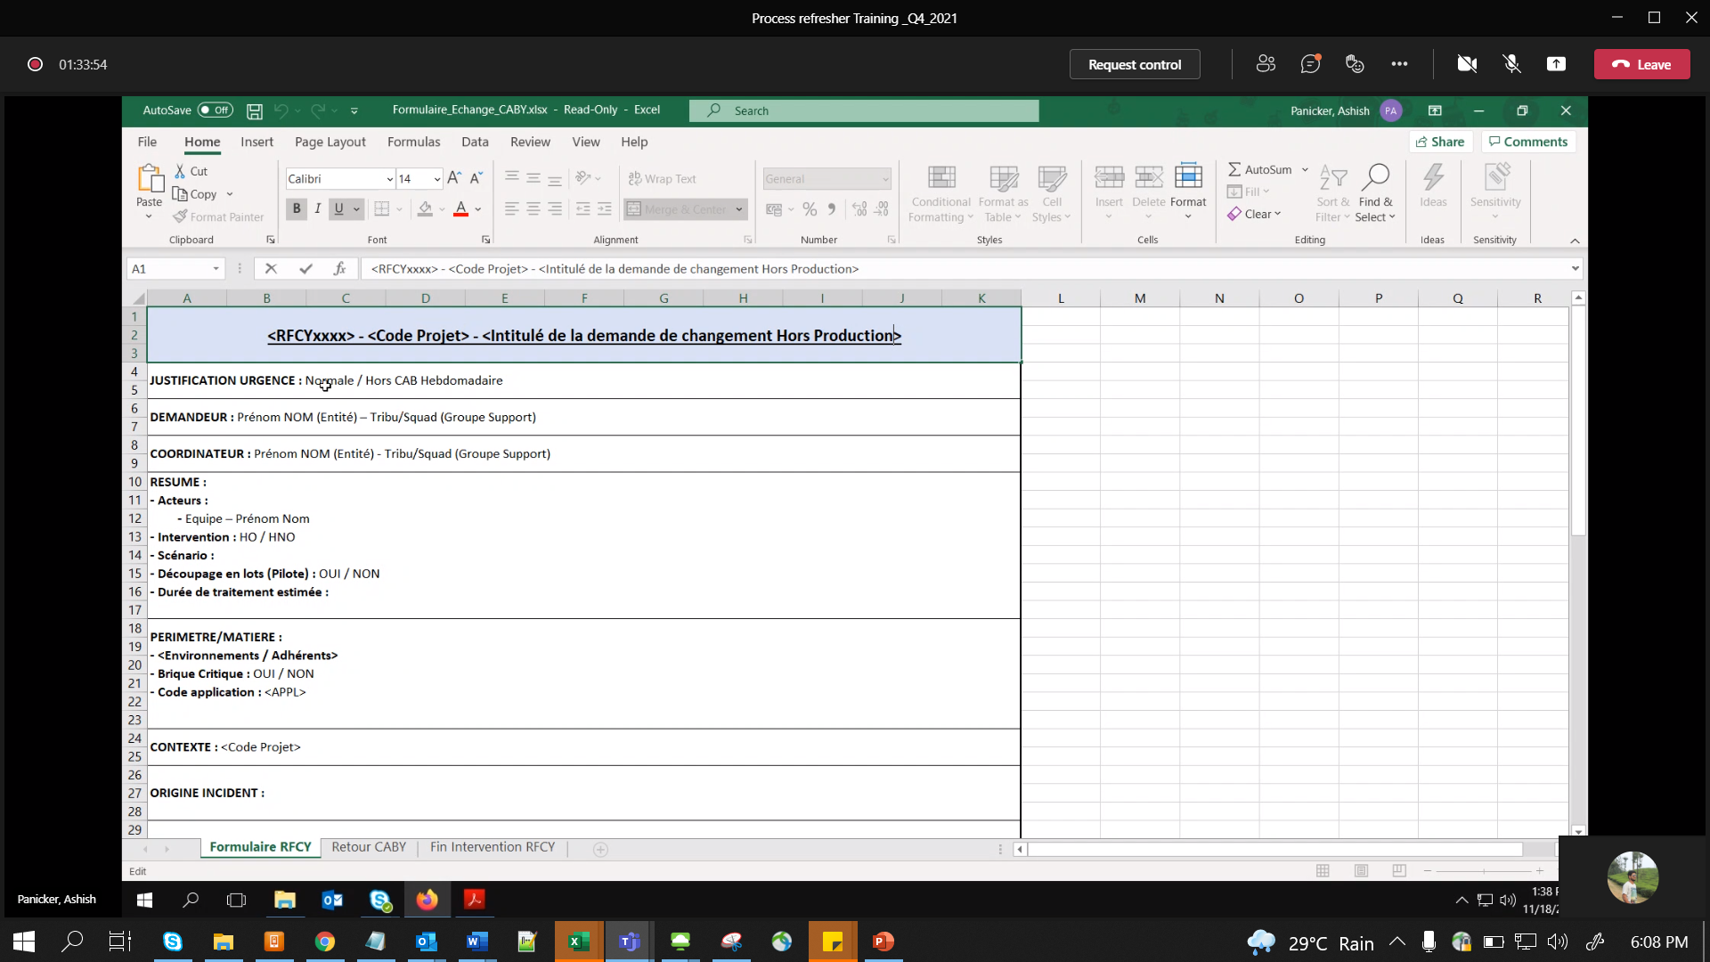

Sent email to (see Commn field )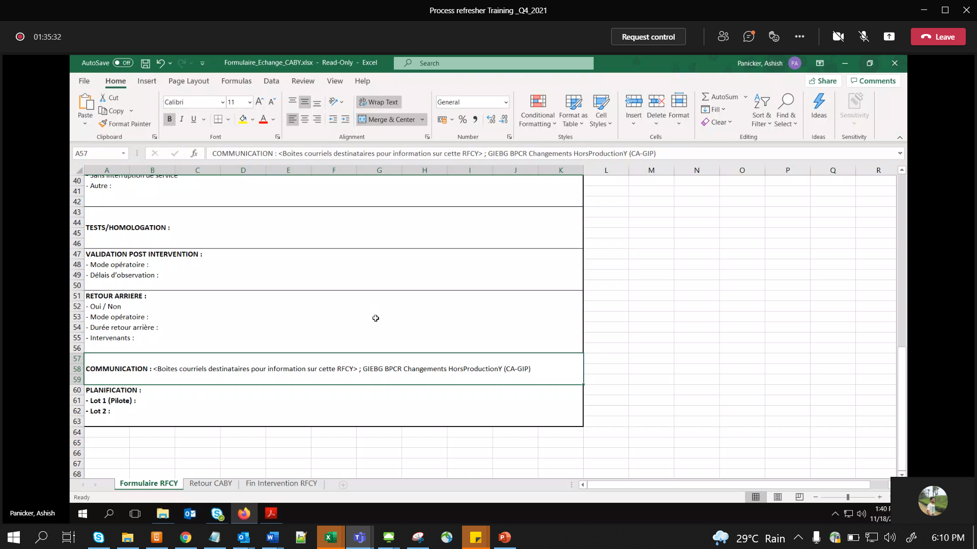

Emergency Change:- atleast b4 48 hrs

Template :- 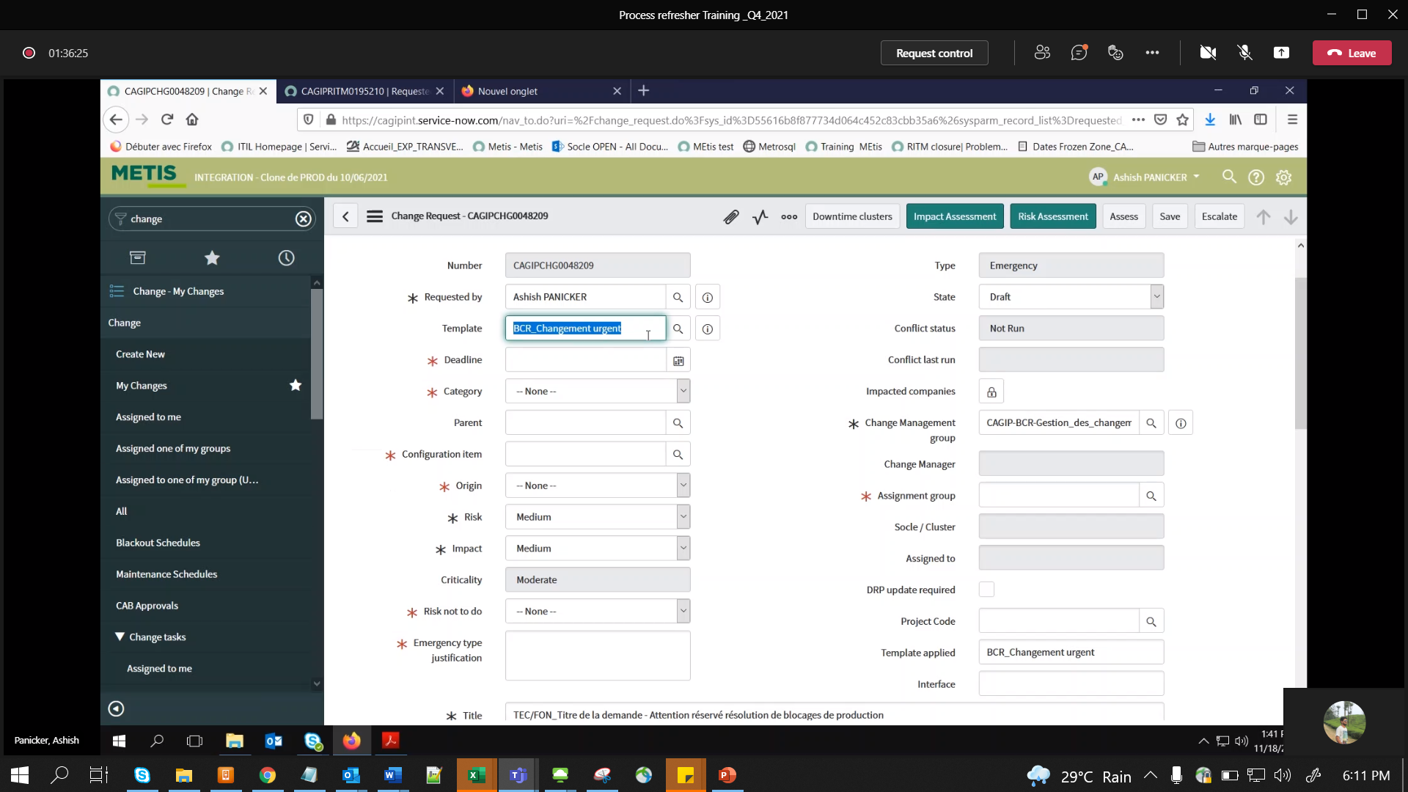

V.IMP – Justification

Send mail to Onshore ODM (Olivier – either we or CM team)

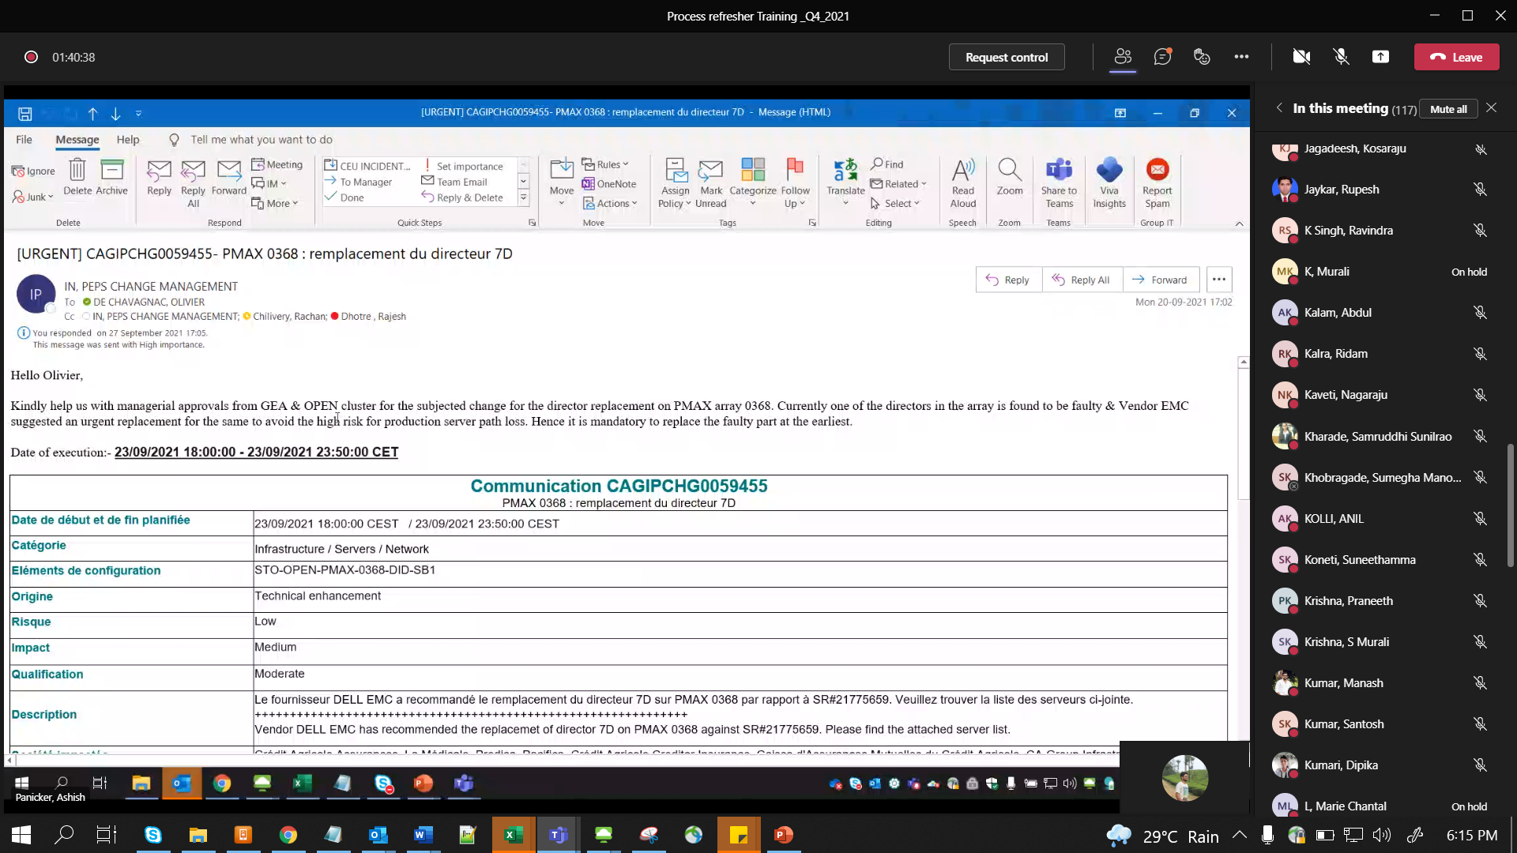

Derogation (During Frozen time)

